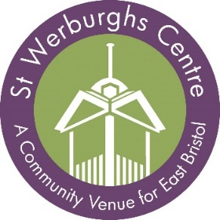

St Werburghs Community Association is looking for a

Centre Assistant

Hours: 30 per week over 4 days.
Salary between £17,364 and £18,791 per annum (FTE) starting at the lower rate.

St Werburghs Community Association is looking to appoint an enthusiastic, capable and reliable individual for this key new role.
The role is to represent the interests of the St Werburghs Community Association and St Werburghs Community Centre in welcoming visitors to the Centre and facilitating a positive user experience for all who come through our doors. The role will provide excellent customer service to members, tenants, event organisers and all visitors to the Centre in a friendly and professional manner.

As Centre Assistant you will have excellent communications and IT skills, and be responsible for facilitating access to the Centre, our room and AV equipment needed for sessions. You will be based at Reception and manage access to our public space including Open Access computers during weekday opening hours.
As part of a small staff team it is essential that the candidate is reliable, self-motivated, enjoys working in a busy environment, can organise and prioritise their own workload, and is proactive. Some experience of the operation of facilities and dealing with the public is essential.

Application Deadline: Sunday 10th October 2021, 12 midnight
Interviews to be held: Thursday 14th October 2021
To start as soon as possible.

To apply the Application Pack is available to download from our website: www.stwerburghs.org.uk
or e-mail Alison Saunders, Finance & HR Manager
to request a pack: alison@stwerburghs.org.uk

PLEASE NOTE – WE DO NOT ACCEPT CV’S

St Werburghs Centre, Horley Road, St Werburghs, Bristol, BS2 9TJ. Tel: 0117 955 1351

Registered Charity No: 1074495, Company Limited by Guarantee No: 3713212

